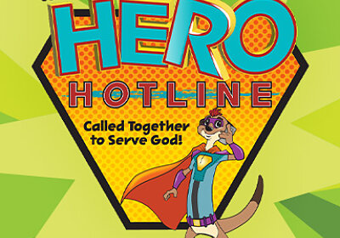

ROCKVILLE UNITED METHODIST CHURCH
Vacation Bible School
142 Grove St, Vernon, CT
Would love to invite you to join us June 26-Jun2 30 2023
For a fabulous week at Vacation Bible School.
The week will be filled with music, snacks, games, crafts, science and stories, and meeting new friends.
Hours are Monday- Friday 9:00 am-12:00
Ages: 3 yrs-12 yrs.
There is a cost – it helps us cover expenses-of $20.00 per child, max $50.00 per family.
(cost will be waived if there is financial difficulties- see Linda Shivers)
Please fill out the registration form and return to Rockville United Methodist Church.
Any questions or if you would like to volunteer (6th grade and up)
Call Linda Shivers- 860-871-9164 or 860-558-7632 or email: necsvga@aol.com

Student’s Name/s:
1.________________________________________________________________
Age:_____________Grade Completed:____________________________
Allergies we should know about?_________________________________________
Friend they would like to be with?___________________________________________

2.________________________________________________________________
Age:_________________Grade Completed:____________________________
Allergies we should know about?_________________________________________
Friend they would like to be with?___________________________________________

3.________________________________________________________________
Age:_________________Grade Completed:____________________________
Allergies we should know about?_________________________________________
Friend they would like to be with?___________________________________________

4.________________________________________________________________
Age:_________________Grade Completed:____________________________
Allergies we should know about?_________________________________________
Friend they would like to be with?___________________________________________

Parent/Guardian’s Name:______________________________________________
Cell phone #:________________________________________________________
Family Address: ______________________________________________________
Town/Zip Code:_______________________________________________________
*Please sign below letting us know if we can take pictures of your child/ren engaged in different activities to post on our church websire/facebook page.

_____________________________________________________________________yes or no ______
Parent signature date circle one

